：
- Cheap performance, where the core part is done by the vertex calculation part of the shader, and the fragment part is just the calculation of simple colors.
- Since it uses the source mesh to achieve shadows, it can also use a lower quality model instead of a higher quality mesh to further reduce the performance penalty.
- It's very close to soft shadows compared to Unity's native Shadow Map quality, and for the most part, it far outperforms Shadow Map

Disadvantages:
- Most importantly, due to its principle, it only works on flat surfaces, i.e. it cannot be applied to sloping or uneven surfaces! Therefore, you should only consider using it if your ground is flat.
- It only has hard shades
- With Stencil buffers, this is no longer a cause for concern, as most devices already support this feature! (including mobile devices)
- Since it can only appear on a flat surface, you can't use it to get the shadows that the rest of the objects cast on your current object.

This pack contents:
This pack contains five shaders, of which Plane is the ground shader used for the demo scene and has no practical purpose, and the remaining four shaders are equivalent to the Lit built into Unity Urp In addition to the basic functions of SampleLit Unlit, there is also a planar projection function.

：Ground height, this parameter determines the position of your projection, please determine this parameter according to the Y axis of the world coordinates where your actual ground is located
：Shadow falloff, this parameter can make your projection more convincing by getting some falloff based on the distance to the center point of your model
：Shadow Color, this option allows you to completely customize the color of the shadow yourself
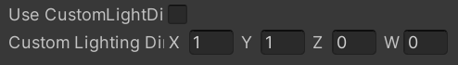
：Custom Light Direction, this option allows you to customize the direction vector of the light by allowing your projection to be independent of the direction of the dominant light!
：Adjusts the overall transparency of the shadow。

Tips：
- Due to the peculiarities of flat shadows, I've turned off Unity's normal shadow casting in the shader, but kept accepting shadows.
- It is highly recommended that you place the axis of the model at the bottom of the model to avoid a lot of problems!
- Why is this package not supported for the HDRP Render Pipeline? Because HDRP is aimed at more high-end PC and console platforms, projects that use HDRP generally require relatively high-quality picture levels, and the many limitations of flat projection are not suitable for high-fidelity images, so I don't plan to support HDRP pipelines for the time being, but this is not absolute! If you really need support for flat shadows in HDRP, please send me an email!

How to use the Rneder Feature for the URP Render Pipeline to improve flat shadow performance？
Flat shadows are excellent! However, in URP, you can't get the performance benefits of SRP Batches if you use a multi-pass shader, so Unity has added the Render Feature feature to indirectly implement the rendering function of shader multi-pass, and flat shadows can of course also use this feature to get performance gains, provided you use enough shaders with flat shadows, say more than five! For this reason, this package includes a separate shader for the projection function, for this purpose, once you think that your project conditions already need to use the Render Feature to improve performance, then your object itself does not need to use the shader with the flat shadow function, the projection will be done for you.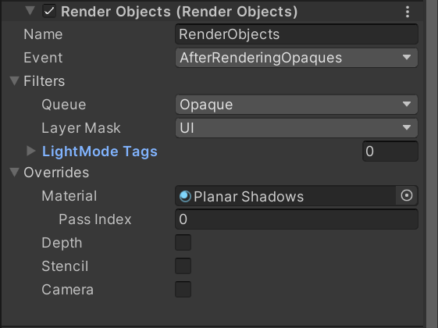
If your URP version already supports Render Ojects, you can simply add Rneder Oject to your current pipeline configuration and use a flat shadow shader to create a shader like the one shown above to get the drop shadow.
Special attention! In the layerMask setting in the diagram, you should not set it to the UI like I did, but instead create a separate layer in the layer for the object you want to project, and set the layer of that type of object to the one you created earlier, and in the Rneder Object, change the setting to the layer you created for the projected object.

If you're not familiar with the URP RenderFeature and Render Object features, you can check out the official documentation and tutorials from the rest of the creators, or ask for my support via email or Discord! It is recommended that you use Discord, which will solve the problem faster!

In the built-in pipeline, there is no SRP Batcher and no Render Feature feature, so you don't have to worry about that, just use the shader with planar projection!

